2.4 Relations and Equivalences
A relation is a more general mathematical object that describes relationship that are not functional.
DEFINITION An r-graph is a directed graph with no multiple edges. That is, for all vertices u,v, there can be at most one edge from u to v.
DEFINITION: A relation on a set S is a subset of $S×S$. If R is a relation on S, we say that "a is related to b" if $\left(a,b\right)∈R$, which we sometimes write as $aRb$. If $\left(a,b\right)∉R$, then a is not related to b.
Example: If $S=\{1,2,3\}$, then the relation on S defined by < is the set $\{\left(1,2\right),\left(1,3\right),\left(2,3\right)\}$.
Example: Let P be the set of all people, living or dead. For any $a,b∈P$, let $aRb$ if a and b are (or were) brothers. Then R is a relation on P, and the ordered $\left(Cory, Emmette\right)∈R$.
Example: Let $a,b∈Z$. If, for some $n∈Z, n|(a-b)$, we say that "a is equivalent to b modulo n". The notation for this relation is $a≡b mod n$.
For example, 1,4,7,10,13…are all equivalent to modulo 3.
Notice that $a≡b mod n ⟺n|(a-b)$
$⇔a-b=kn for some k∈Z$
$⇔a=b+kn for some k∈Z$
So adding any multiple of n to a number b gives a number that is equivalent to b modulo n.
DEFINITION: Let R be a relation on a set X. The directed graph associated with (X,R) is the graph whose vertices correspond to the elements of X, with a sirected edge from vertex x to vertex y whenever xRy.
Example 1: Construct a directed graph of the "divides" relation on the set $X=\{2,3,4,6\}$.
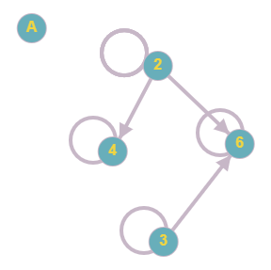

A couple of notes about that directed graph. Every element has a loop attached since each number divides itself. We don't need to put an arrow on the loop since the loop can work in both directions.
Much like Section 2.1, the placement of the vertices in this graph doesn't matter. I put them in a diamond, but any formation is fine. The connections are the important part.

A relation is symmetric if it has the property that $xRy if and only if yRx$. For a symmetric relation, the arrows would come in pairs, one in each direction. In this case, we replace the two arrows with a single edge and omit the arrowheads.
DEFINITION. Let R be a relation on a set X, and suppose $xRy ⇔yRx for all x,y∈X$. The undirected graph associated with (X,R) is the graph whose vertices correspond to the elements of X, with an (undirected) edge joining any two vertices x and y for which $xRy$.
Example 2: Define a relation on the set $X=\{2,3,4,6\}$ by setting $aRb$ whenever $ab<13$. Since $ab<13⇔ba<13,$ this is a symmetric relation. Draw a graph of this relation.
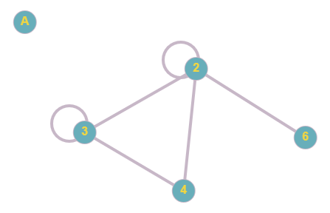

All of the edges are undirected. This tells us that the relation works in both directions. For example 2R4 and 4R2.
What's the difference between a relation and a function?
A relation on X is a function $X→X$ if each $x∈X$ occurs exactly once as the first element of an ordered pair. In other words, for any given x, there can be only one y that corresponds to it.

Example 3: Let $X=\{2,3,4,5,6,7,8\}$, and say that two elements $a,b∈X$ are related if $a|b and a≠b$. Draw a directed graph for this relation.
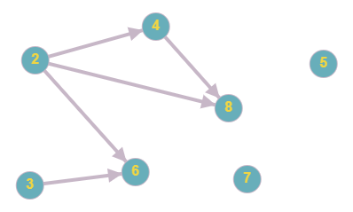
Notice that we don't put any loops on the numbers because we have the added condition that $a≠b$. So no element is related to itself.
Equivalence Relations
DEFINITION A relation R on a set S is an equivalence relation if it satisfies all three of the following properties.
- Reflexivity. For any $a∈S, aRa$
- Symmetry. For any $a,b∈S, aRb⇔bRa$
- Transitivity. For any $a,b,c∈S, if aRb and bRc, then aRc.$
In other words, an equivalence relation is a relation that is reflexive, symmetric, and transitive.
Example 4: Let S be the set of all symbols $\frac{x}{y}$, where x and y are integers with $y≠0$. In other words, $S=\{\frac{x}{y}|x,y∈Z, y≠0\}$. Define a relation R on S as follows. For any elements $\frac{x}{y}$ and $\frac{z}{w}$, $\frac{x}{y}R\frac{z}{w}$ if $xw=yz$. Prove that R is an equivalence relation.
(We prove each property separately.)
Proof: Reflexivity. (We always start the proof of reflexivity by taking an element of the set.) Let $\frac{x}{y}∈S$. (Next, we have to show that this element is related to itself. In this problem, $\frac{x}{y}R\frac{x}{y}$ means xy = yx. We know this by plugging them into the formula given in the problem.) Since $xy=yx$, we can say $\frac{x}{y}R\frac{x}{y}$.
Symmetry. (We always start the proof of symmetry by taking two elements in the set and assuming the first is related to the second.) Let $\frac{x}{y} ,\frac{z}{w}∈S$ such that $\frac{x}{y}R\frac{z}{w}$. (Now unpack this and use math to show that the second is related to the first. In this problem, we need $\frac{z}{w}R\frac{x}{y}$ which means $zy=wx$.) So $xw=yz$. Because the order of multiplication doesn't matter, this is the same as $zy=wx$, so $\frac{z}{w}R\frac{x}{y}$.
Transitivity. (We always start the proof of transitivity by taking three elements in the set and assuming the first is related to the second AND assuming the second is related to the third.) Let $\frac{x}{y},\frac{z}{w}, \frac{p}{q}∈S$ such that $\frac{x}{y}R\frac{z}{w}$ and $\frac{z}{w}R\frac{p}{q}$. (Now we unpack those and use math to show the first one is related to the third one. In this problem, that means $\frac{x}{y}R\frac{p}{q}$ which means $xq=yp$.) So $xw=yz and zq=wp$. Then $xq=\left(\frac{yz}{w}\right)q$ (by solving the first equation for x.
Then $\left(\frac{yz}{w}\right)q=\frac{y}{w}\left(zq\right)=\frac{y}{w}(wp)$ by subbing in the second equation.
Then $\frac{y}{w}\left(wp\right)=yp$. So we've shown $xq=yp$, so $\frac{x}{y}R\frac{p}{q}$.

A partition of a set S is a set P of nonempty subsets of S with the following properties.
- For any $a∈S$, there is some set $X∈P$ such that $a∈X$. The elements of P are called the blocks of the partition.
- If $X,Y∈P$ are distinct blocks, then $X∩Y=∅$.
THEOREM 2.2 Let R be an equivalence relation on a set S. For any element $x∈S$, define $R_{x}=\{a=X|xRa)$, the set of all elements related to x. Let P be the collection of distinct subsets of S formed in this way, that is, $P=\{R_{x}|x∈S\}$. Then P is a partition of S.
The sets $R_{x}$ are called the equivalence classes formed by the equivalence relation. A simple way to think of an equivalence class: "The equivalence class of element 'a' is the set of all elements related to 'a'."
Here's a little example.
Example 5: The following is a graph of an equivalence relation. Find the distinct equivalence classes.

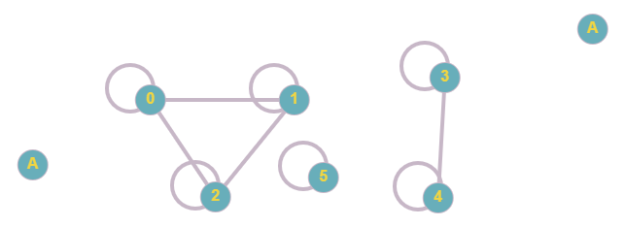

We can start at any element. We'll start at 0.
So the equivalence class of 0 is written as $\left[0\right]=$ the set of all elements related to 0.
$$\left[0\right]=\left\{0,1,2\right\}=\left[1\right]=[2]$$
Notice that the equivalence class for 0 is the same as the equivalence class for 1 and 2.
$$\left[3\right]=\left\{3,4\right\}=[4]$$
$$\left[5\right]=\{5\}$$
5 is the only element in its equivalence class since it's not connected to any other elements.
So the distinct equivalence classes are $\left\{0,1,2\right\}, \left\{3,4\right\},\left\{5\right\}$

HOMEWORK: #1, 3, 9, 13, 14, 15, 17, 21, 22, 23, 27

